Vegan “Cheese” Fondue (Gluten Free)

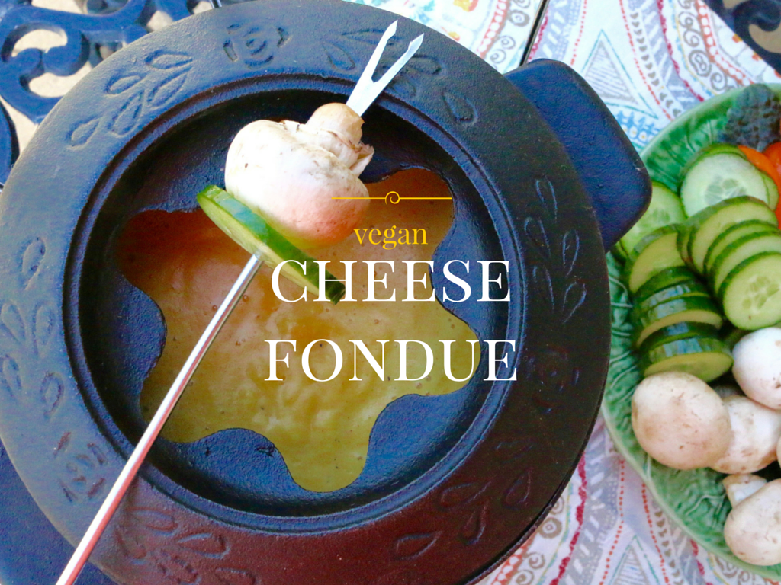

Fondue is such a fun, interactive meal. Just serve a thick, warm dip with a variety of breads and veggies, and let people dip to their hearts content. It’s a wonderful winter time meal (right after a day skiing is the best!), but it also works just about any time of the year. Fondue is traditionally made with cheese, but that doesn’t mean plant-powered eaters have to skip this tradition altogether. I used yellow, waxy potatoes to create a healthy, plant-based “cheesy” fondue perfect for dipping with vegetables, tofu, and bread cubes.

Vegan “Cheese” Fondue (Gluten Free)

1 pound small, fresh yellow potatoes (i.e., Yukon gold, fingerling), peeled*, quartered
2 medium carrots, chopped
1 tablespoons extra virgin olive oil
1 yellow onion, diced
2 cloves garlic, minced
2 tablespoons cornstarch
1 cup dry white wine (i.e., Chardonnay)
½ cup reserved potato water
½ cup unsweetened, plain plant-based milk (i.e. soy or almond milk)
¼ teaspoon white pepper
¼ teaspoon turmeric
Pinch nutmeg
2 tablespoons nutritional yeast
2 tablespoons Dijon mustard
Salt to taste
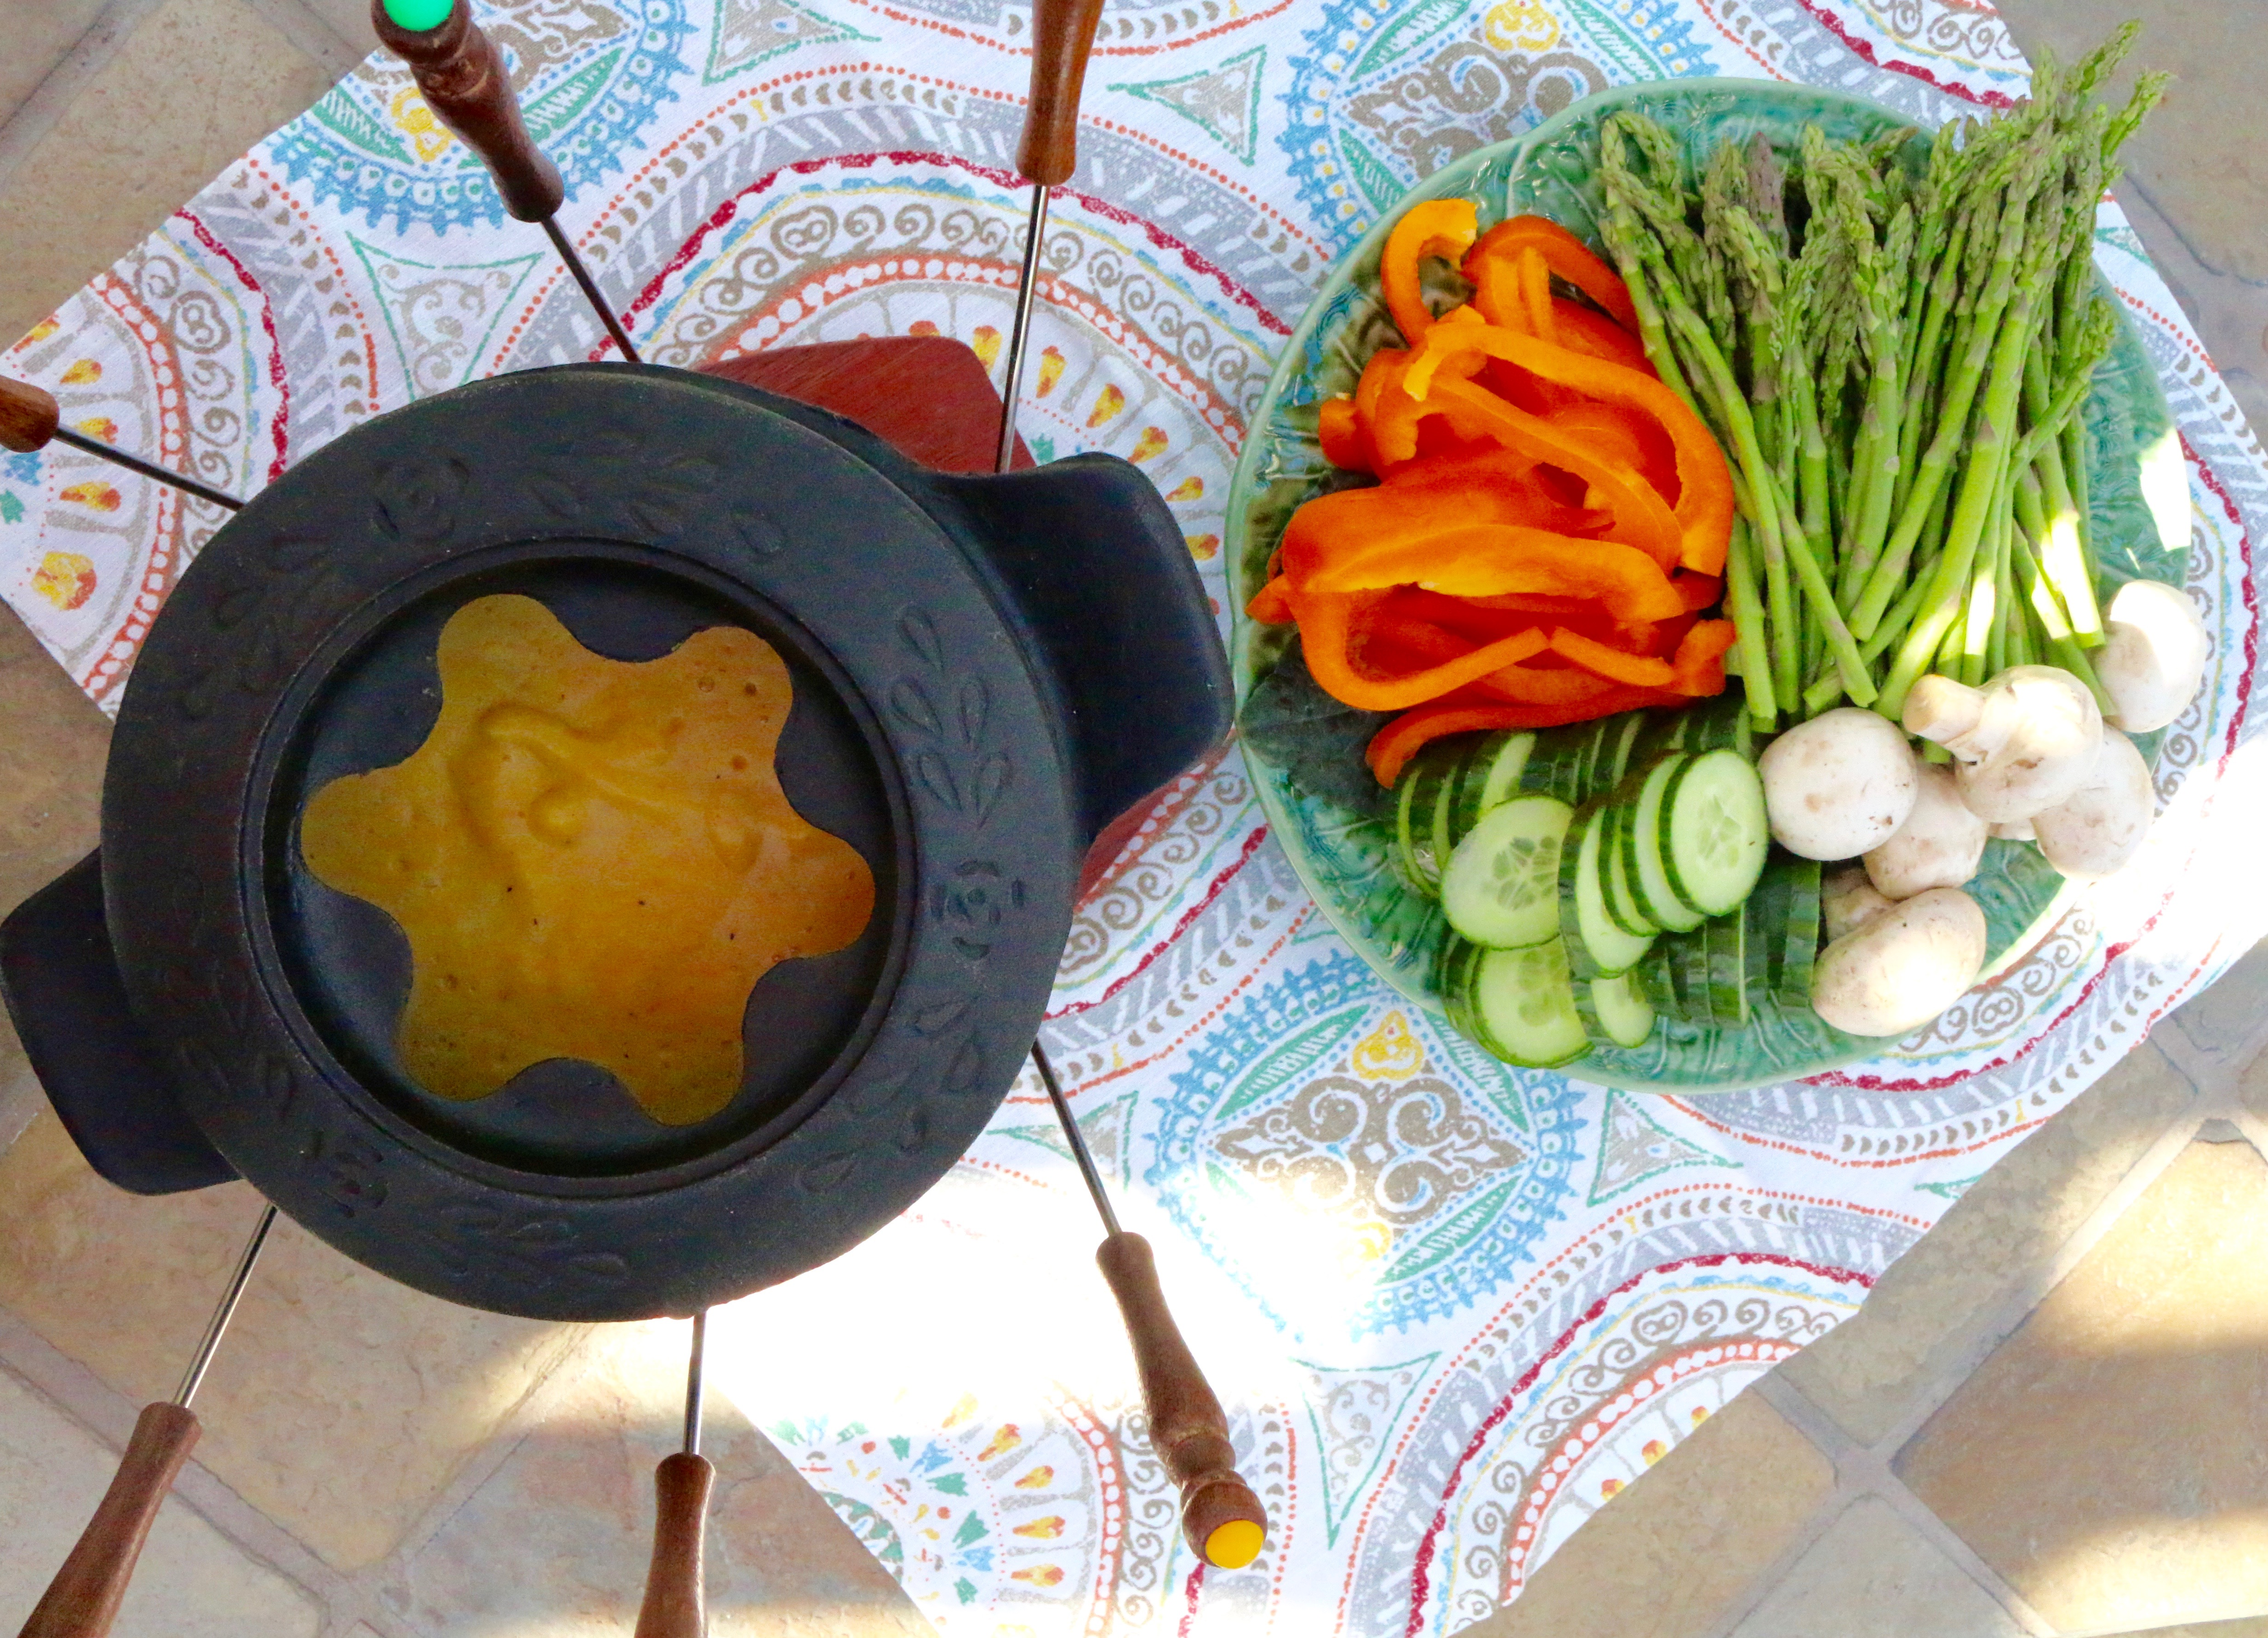
Dipping Ideas
Serve this fondue with your favorite plant-powered dipping items, such as:

Cubed tofu
Seitan strips
Veggie Sausage chunks
Cube seitan
Bell pepper chunks or strips
Mushrooms
Broccoli florets
Cauliflower florets
Cucumber slices
Asparagus spears
Snow peas
Bread cubes
Pita triangles

- Place potatoes and carrots in a medium pot, cover with water, cover with a lid and cook for about 10 minutes, until tender. Drain, reserving ½ cup water, and place cooked vegetables in a blender container.
- While potatoes are cooking, heat olive oil in a large skillet and add onions and garlic. Sauté until tender, about 8 minutes. Add onions and garlic to the blender container.
- In skillet (do not clean), add cornstarch and white wine and stir with a whisk over medium heat. Stir in reserved potato water and plant-based milk until smooth. Add pepper, turmeric, nutmeg, nutritional yeast and mustard and heat until thickened and bubbly.
- Pour white wine mixture into the blender container with the potatoes and onions and process until smooth. Adjust seasonings with salt as desired.
- Transfer fondue mixture to a fondue pot and heat until bubbly.
- Serve with dipping ideas, such as cubed pieces of bread, fresh vegetables, and tofu.
*You can peel these potatoes easily if you cook them first, and then slip off the peels when they are done.

Makes 8 servings

